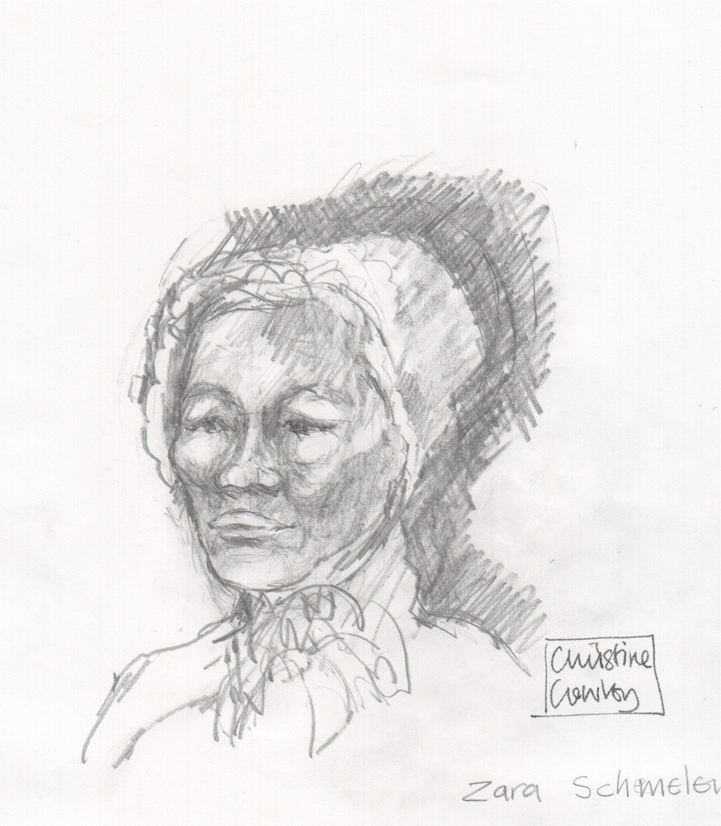

ZARA SCHMELEN (1793-1831)

Ne //goe /howati //aegus ge, ≠an da as gose, Zara Schmelensa, neba ge ≠âi herasa !oa, Botma Hofs, Heunig Bergi !ab ai //goeb, ai a //osa. //îs ge !Hoa - ≠Kheib di tsoatsoas, 1831 //î guri ge //o. //îs ge //îs aob, //Kha-//kha aob Hinrich Schmeleni, /khas oa !goaxa Kommagas, Noord Kapi !nâ //goes //ga, hîa ge a //o. //îs aob Hinrichi ge 1848 ge //o, tsî //gau mâi he hâ /howas, Kommagas !nâ //goes !nâ a //khosa.
Zaras ge Nama-Khoena xu ge ≠oaxa hâ i, tsîs ge Khoi-khoi gowaba gere !hoa. //Îs ge //is aob Hinrichi, hîa ge Deutschlanda xu ≠oaxa hâ ib tsi London’s //Kha-//kha aogu di !nans xa Nama !Hub //ga sî he hâ ib, /kha !Garieb !ab xo /kha //goe !as, Pellas ais //gausa ra ≠gâ hîa ge /hao. //Îb ge aitsama ge !gamera, 1814 gurib !nâ. Nes ge Namibiab di !kawagas !nâ ge isa. ≠Gui !gôab di Nama Khoen //îra /kha ge doe gau in ai-!âb ge //îba !gameb di Literxiba di toa tsî ge mî //gui “Nes /kha ta ge Zaras /kha go !game” ti.
//Îra ge Kerkib di berosa Bethanis, hîa Namibiab di !khawagas !nâ //goes, ai ge tsoa-tsoa. Xawera ge ega Kapi //ga ge oa. Neba ra ge Jasper Cloeteb, Kamiesbergs tira ≠gaihe !asa xu gere /khib xa //khauhe tsi Kommagas die Kerkib berosa ge //kowa-am.
Zaras tsî Henrichi tsira ge //îra ûi gurigu hoaga kaise /gugu se gere sîsen /hao. //îs ge //îba ao-//nâ di âb /kha gere hui, Nama gowab !nâ. //Îra ge //khadi ≠guro Nama Gowab di grammaba ge xoa tsî nam-≠gaudi //gau-//gau te ge guru. //Nas khao !gâ rage 4 !gai-≠hoadi /gu-/garus di te ge ≠nûi-!khuni, Nama gowab //ga.
≠Guro !nas hîa rage ne ≠nui !khunisa ≠khanisa Kapi //ga a !nari us ai die ge gomte ne horaga ≠khanisa ge gom-≠ûi. O ra ge //khawa ≠nûi !khuni tsi 1831 //î guri ≠guro Nama gowab di /Gu-/garusa ge //gai //nâ (“print”).
/Gu-/garus !nâns di //gai-//nâ aon (printers) ge aibe ge !âu, nam-≠gaugu !aroma i /gurihâ guru nûte ni di hes gose! Nes ai !â i ge /gui khoma tsâ ≠khani i tsîna Nama gowab !nâ xoa he tama ge hâ i.
Zaras ge amase ge /o-aisa i tarasa, kai ses ge Nama Khoen die ≠usib !oagu /gaisa se ge //gui ≠gasen.
//îs //khos tawa, ne da mabab ge //Kha-//khaob, Gustaf Zahni, Steinthal Kerkib, Tulbaghi diba Hebre //în di 12 dana !as, 1-2 //î //ara !ara xu neti ge khom ai:
1). //Na amaga //khadi sada, neti go kai /hu-/gui timi aon di /nanu e da sada #namibe uha amaga da !gomi hoab tsi huga /guira #ai ai da //oreba //gui //na ida satsisib /kha sada mai ba he ha !Kami //ga !gu.
2). Ida Jesub, #goms di #gai-#gui tsi di-toa aob ei go !awa; //ib //gui ei-!abaheb ge ha i !gaia #gaob di am !nas !na !gou-heiba ge tsab , taosiba #gao tama i, tsi elob trons di am-/khab //oab ai #noaba.
Tsâba //hao !oabas, 18 /as Tara //khumu //kâb dis 2014 //I gurib ai ge neba a di hes aib ge Zaras die surib tsî /hosan tsîna kai !gôasiba //îsa ge ma. Anna Makatees,Khoese gurixas /guise is, //khaisa suriga Zara sa xu hâs, ge //khaba ne go gawise a mîhe !âsa Hebre //î ≠khanisa xu ge khom ai.

ZARA SCHMELEN(1793 – 1831)

Amongst these graves lies, to the best of our knowledge, Zara Schmelen who died here on what we believe was Botma’s Hof at the Heunig Berg on the Berg River. She died on an early April day in 1831. She, with her missionary husband Hinrich Schmelen, were travelling back to their station at Komaggas in the Northern Cape. She was not yet 38 years old. Consumption (TB) was the cause of her demise. Hinrich died in 1848 and has a marked grave in Komaggas.

Zara was from the Namaqua people and spoke the Khoi dialects. She first encountered Hinrich, born in Germany and sent to Namaqualand by the London Missionary Society, when she was a catechist at Pella on the Gariep (Orange) River. He married himself to her in 1814 somewhere on the plains of Great Namaqualand, today Southern Namibia. In front of the large group of Nama people trekking with them, he declared one morning, after performing the church’s marriage service rituals that “I herewith marry myself to Zara”.

They started the mission station in Bethanien (Southern Namibia) but later had to return to the Cape where Jasper Cloete, originally from Kamiesberg, invited them to settle and build the Komaggas mission station.

Zara and Hinrich collaborated closely throughout their life. She helped him deliver each of his sermons in the Nama languages. Together they compiled the first Nama grammar and invented a written form of the different ‘click’ sounds. This done, they translated the four Gospels into Nama. When they first took the translation by wagon to Cape Town to have it printed, termites had entered the box in which the translation was kept and ate their pioneering work. They started again and in 1831 went to Cape Town for the first Nama Bible to be printed.

The Bible Society printers had to delay printing the Nama Bible for several months while they waited for lead letters to be cast that represented the ‘click’ sound. No publication in Nama had been printed before.

Zara was a remarkable woman for her contribution to Nama culture over 200 years ago.

At her funeral service at this location, the missionary Gustaf Zahn from the Steinthal mission in Tulbagh, read from Hebrews 12, verses 1 and 2:

Therefore, since we are surrounded by such a great cloud of witnesses, let us throw off everything that hinders and the sin that so easily entangles. And let us run with perseverance the race marked out for us,

Fixing our eyes on Jesus, the pioneer and perfecter of faith. For the joy set before him he endured the cross, scorning its shame, and sat down at the right hand of the throne of God.

At a memorial service on 18 September 2014, a gathering of her descendants and friends from different parts of the world came together here to pay their respects to Zara Schmelen. Anna Makatees, nine years old and a descendant eight generations after Zara, once more read the verses from Hebrews at this place.

