Ziziphus mucronata Willd. subsp. mucronata
Family: Rhamnaceae
Common names: buffalo thorn (Eng.); blinkblaar-wag-'n-bietjie (Afr.); umphafa, umlahlankosi, isilahla (isiZulu); umphafa (isiXhosa); umlahlabantu (Swazi); mokgalo (Tswana); mutshetshete (Venda); mphasamhala (Tsonga); mokgalô, moonaona (N Sotho)
SA Tree No: 447
View other plants in this family QR code link View other plants in this genus
Ziziphus mucronata, or as it is more frequently known, the wag-'n-bietjie tree represents life as we know it. The young twigs are zigzag, indicating that life is not always straightforward. Two thorns at the nodes are also significant; one facing backward represents where we come from and one facing forward, represents where we are going.
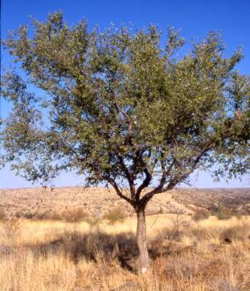

Description
Ziziphus mucronata is a small to medium-sized tree, 3-10(-20) m high; with a spreading canopy. The main stem is green and hairy when young; year old branches often zigzag; the bark is reddish brown or roughly mottled grey, cracked into small rectangular blocks, revealing a red and stringy under-surface. Young stems are reddish brown.
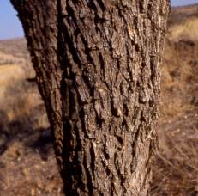
Leaves are simple, alternate; ovate or broadly ovate; vary enormously in size from tree to tree, 30-90 x 20-50 mm, tapering or often mucronate apex, base strongly asymmetrical, cordate to rounded on one side; margin finely serrated, often badly eaten by insects, glossy green above, slightly hairy and paler below; 3- to 5-veined from the base; veins covered with fine hairs when young; petiole up to 20 mm long; stipules, when present, take the form of small thorns at the nodes, one straight and one hooked. Leaves turn golden yellow in autumn.
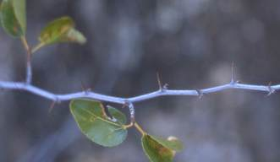
Flowers are borne in dense clusters in leaf axils; green to yellow; ± 4mm in diameter; inconspicuous (October-February). The fruit is a smooth, shiny, leathery, spherical drupe, 12-20 mm in diameter, reddish-brown or deep red when ripe, slightly sweet, the pulp is dry. The fruit sometimes stays on the plant long after the leaves have fallen (March-August). The seeds are usually solitary, elliptic and compressed.
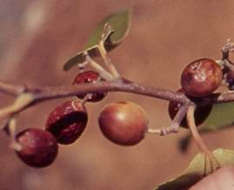

Conservation Status
Red Data status : Not evaluated (NE).

Distribution and habitat
The buffalo thorn is distributed throughout the summer rainfall areas of sub-Saharan Africa, extending from South Africa northwards to Ethiopia and Arabia.
Ziziphus mucronata grows in areas dominated by thorny vegetation in both temperate and tropical climates. It is also found in a wide range of habitats such as woodlands, open scrubland, on rocky koppies, open grasslands, on a variety of soils along streams, nutrient-rich valley bottoms and forest margins. It reaches its largest size on the margins of scrub forest and on deep, alluvial soils near water. Its presence is said to indicate the presence of underground water.

Derivation of name and historical aspects
The ancient Greeks called the tree zizyphon, from the Arabic zizouf, a name for the mythical lotus. This was taken into Latin as zizyphum, or zizypha for the fruits. The species name mucronata is Latin meaning pointed, probably referring to its thorns or the apex of its leaves. The stipular thorns at the nodes give the tree its common Afrikaans name of wag-'n-beetjie. For all their smallness, these thorns are extremely vicious, and all those who have come into contact with them,will know that you have to wait-a-bit if you want to free yourself from them.
There are 49 genera and 900 species in the family Rhamnaceae (Simpson 2006). The genus Ziziphus includes some 86 species, of which the one discussed here is among the most common and best known trees of southern Africa. Another well-known species in this genus is Z. mauritiana, the ber or jujube tree, the fruits of which are often found in shops which sell Asian foodstuffs.
Historically, the genus is of interest. Christ's crown of thorns is supposed to have been made from Ziziphus spina-christi Willd., a species which closely resembles Z. mucronata but which grows from central Africa northwards (Palmer & Pitman 1972).

Ecology
Although the fruit of Ziziphus mucronata cannot be counted as very tasty, the tree itself plays an important role ecologically. The leaves and fruit are sought after by birds of many species, wild animals and domestic stock. Giraffes are known to be especially fond of the leaves of this tree. Impala often feed on the dead leaves lying under the tree. Its inconspicuous, green to yellow flowers produce abundant nectar and often yield a good honey.
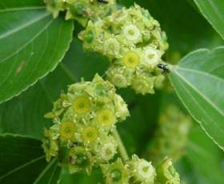

Uses
A decoction of the glutinous roots is commonly administered as a painkiller for all sorts of pains as well as dysentery. A concoction of the bark and the leaves is used for respiratory ailments and other septic swellings of the skin. Pastes of the root and leaves can be applied to treat boils, swollen glands, wounds and sores. Steam baths from the bark are used to purify and improve the complexion (Palmer & Pitman 1972). In East Africa, roots are used for treating snake bites (Hutchings et al. 1996). All of the above can be attributed to the peptide alkaloids and antifungal properties isolated from the bark and leaves.
The berries are edible and were used by residents in the former Transvaal in making porridge or as a coffee substitute. The fruit can also make a beer if fermented properly. During the Anglo-Boer war, the seeds were ground and used as a coffee substitute.
Africans have many beliefs and superstitions attached to this tree. Zulus and Swazis use the buffalo thorn in connection with burial rites. It was once customary that when a Zulu chief died, the tree was planted on his grave as a reminder or symbol of where the chief lies. Hence the name umLahlankosi- that which buries the chief. A twig from the tree was and is still used to attract and carry the spirit of the deceased from the place of death to the new resting place. When a stock owner died, and was buried according to custom, within the cattle or goat kraal, some branches were placed on the grave so that the animals nibbled on leaves and twigs, and so understood that their master had died (Palmer & Pitman 1972). In other parts, Africans drag a branch round the village to protect it from evil spirits, as it is believed to keep evil spirits away.
In Botswana as well as most parts of South Africa, the residents believed the buffalo thorn to be immune against lightning, anyone standing under one in a storm would be safe. It is also believed that if it is felled in summer, a drought, hail or lightning will certainly follow.
Wood from this tree is used for timber, wagon making and fence posts as it yields a yellow, fine-grained, heavy wood which contains 12.2-15.7% tanning matter (Watt & Brandwijk 1962). The elasticity of the shoots makes it suitable for bows and whip sticks. Some African tribes use the thorny branches to make kraals or hedges. This protects their livestock from lions and other predators.

Growing Ziziphus mucronata
The species is very easily raised from seed or cuttings, growing in just about any soil type and withstanding heat and cold equally well.
The seed however has poor keeping properties and should be sown fresh. After cleaning the nut, it can be placed between the jaws of a vice or a normal nutcracker and closed gradually until the nut cracks and seed is released. The seeds can then be covered with hot water, allowed to cool, soaked for two days and sown.
Seedlings should appear within one to two weeks. Seedlings and small plants need moderate water, full sun and efficient drainage or they will damp off. Even though this plant is said to be one of the most adaptable trees, growing in all types of soil and having the ability to withstand intense heat, cold and drought, the same cannot be said for the seedlings. As with most plants, immunity is acquired with increased stature. Small trees are often available at nurseries selling indigenous plants.
While slow-growing (0.3 m or less per annum), it makes a pleasant shade tree and gives life to the garden by luring birds and insects such as butterflies, beetles and bees.

